How affordable are Dublin residential properties for First-Time-Buyers under typical mortgage condition?

  - Introduction
It’s common knowledge that the housing crisis surrounding the Dublin area is becoming more and more endemic. For the past few years, people have been concerned if they will someday be able to afford their own dwelling house. After ‘The Irish Banking’ crisis (2008-2013) the Irish property market was affected by increases in house prices and rents, for these reasons, The Central Bank of Ireland set up a series of regulations to ensure sustainable lending standards in the mortgage market (Central Bank of Ireland, 2023)
First-Time-Buyers (FTB), have better conditions than second or investment buyers, such as a 4x income limit, macroprudential exemptions, lower interest rates and also government incentives. However, the Irish property market is competitive, and most of the time the announced price is not nearly the same as the sold price. In this way, the amount obtained through a mortgage by an FTB might not be enough to buy a house, and this gap needs to be filled with more savings or postpone the idea of getting your own house.
  - Problem Definition
As the housing crisis is affecting housing prices, there is a strong likelihood FTBs might not be able to afford a house purchase in the future. To predict whether this could jeopardise mortgage applications, predictive modelling can foresee an average price of houses and with data provided by The Central Bank of Ireland about First-Time-Buyer lending indicator we can compare these values to determine whether they are sufficient or other measures must be taken to fil the gap between loans and house prices.
  - Aim and Objectives
The aim of this project is to assess the estimated housing affordability for First-Time-Buyers in Dublin by analysing residential property prices, predicting prices using machine learning and comparing the results with aggregate mortgage lending indicators.
  - Objectives
- To analyse residential property prices in Dublin and identify differences across areas, property types and market-price status;
- To prepare and clean the Property Price Register and Central Bank of Ireland mortgage lending datasets;
- To develop a Linear Regression model to predict residential property prices using relevant features available in the Property Price Register;
- To evaluate the predictive model performance and confirm if this method has acceptable accuracy
- To compare observed and predicted property prices with first-time-buyers mortgage lending indicators to assess estimated affordability across Dublin areas.
  - Scope
For this first Capstone, we have two main datasets to analyse. The first and principal dataset is Property Price Register Dublin (PPR), covering 2023-2026. These data provide the price paid on properties sold, the date sold, whether the property is a second-hand or new dwelling house, the county (Dublin), whether the property was sold at the full price market or not, as well the address, Eircode, VAT exclusion and Property Size Description.
We are also analysing the “New Mortgage Lending Data 2025” dataset. This dataset will be used to compare the average loan values for FTBs with the market price and assess how affordable Dublin residential properties are for First-Time-Buyers under typical mortgage condition. However, the PPR dataset contains a large number of outliers, depending on the area where the property is located, the cost of buying a house can vary considerably. For this reason, an analysis comparing average prices by neighbourhood might be interesting and it is consistent with our ideas. Another valid variable to be considered is whether the FTB can afford new houses, second-hand property or their budget does not interfere in their choices, since they also have government incentives to assist with their acquisition.
  - Methodology
To reach a conclusion, we will use Phyton to gather facts, check outliers, calculate the mean and median, and clean the data to be able to understand and use just relevant values, check whether the entire dataset is legible. After all data preparation, we will be using relevant columns. For the PPR dataset, these will be price sold, full market price, description of property, county, area. For the New Mortgage Lending Data 2025 dataset, loan size, property value, loan to value, income, loan to income and loan term. At the end, we will likely have enough information to compare prices and FTB estimated affordability to develop a Machine Learning model to predict property prices and using a Linear Regression we can evaluate our results. However, if the Linear Regression does not achieve good accuracy, another ML model might be considered.
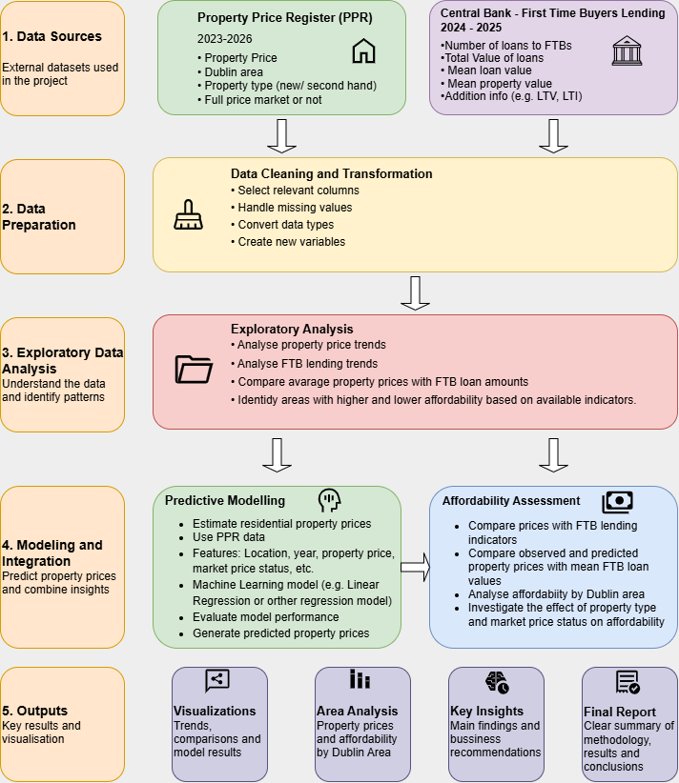
  - Data Sources
The main dataset used is Property Price Register Dublin (PPR), acquired online from the Property Price Register website. It contains 19.324 rows and 9 columns, with 1 numerical column (Price), and 8 categorical columns. To support this dataset, we also have “New Mortgage Lending Data 2025” dataset, published online by The Central Bank of Ireland, which will give us an average of FTB mortgage data for the years 2024 and 2025.
  - Expected Deliverables
At the end of this project we expect find a clear outcome showing what barriers that mortgage applicants might face trying to acquire a house. Due to the crisis situation, it is apparent that the current conditions are not favourable for simple applications, and more than one resource is needed to complete the request.
To estimate prices, we will use Linear Regression with historical data such as year, area, type of property and if it was sold at full market price, to find our target, the selling price. However, if the independent variables permit, we also can compare the results from Linear regression with a Decision Tree model and check which one gives us a better accuracy.
  - Project Timeline

  - Ethical and Legal Considerations
To comply with the GDPR and protect personal data, some of our columns will not be used in full, such as Eircode and address.
On the Property Services Regulatory Authority website, you can find the following warning:
“The Property Services Regulatory Authority complies with the Regulations on the Re-use of Public Sector Information (S.I. No. 279 of 2005) and we encourage the re-use of the information that we produce.
All of the information featured on our website is the copyright of the Property Services Regulatory Authority unless otherwise indicated.
Re-use includes copying, issuing copies to the public, publishing, broadcasting and translating into other languages. It also covers non-commercial research and study.”
The Central Bank of Ireland’s New Mortgage Lending data will be reused in accordance with the applicable Creative Commons Attributions 4.0 licence and the Bank’s re-use conditions.

